# **CS 255 System Design Document Template**

## UML Diagrams

### UML Use Case Diagram

Use case diagram completed in Project One. Main use cases: Register/Login, Schedule Lesson, Modify/Cancel Lesson, Take Online Course, Take Practice Test. See attached use case PDF.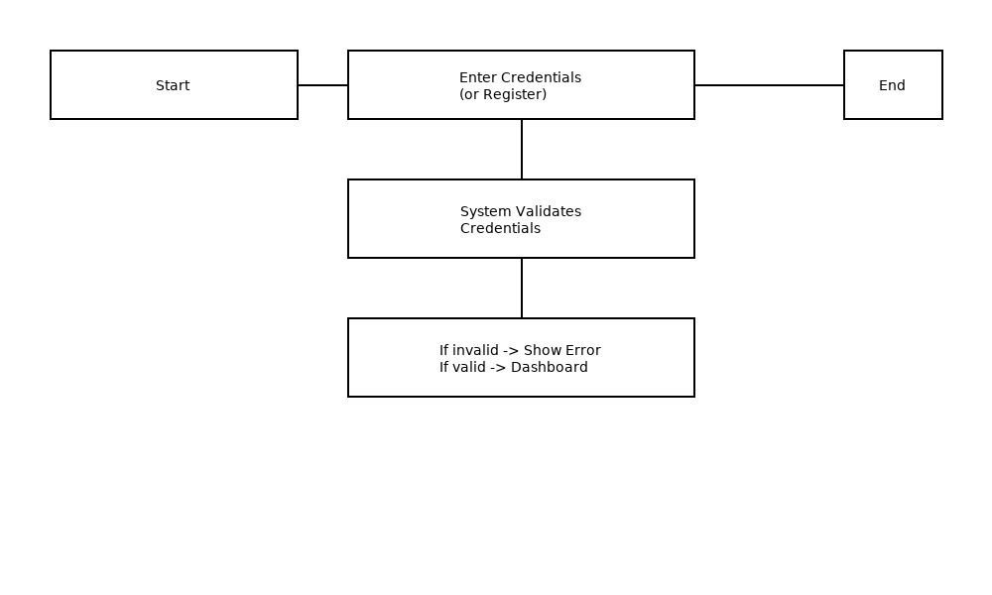

### UML Activity Diagrams

Activity Diagrams provided for two use cases: 1) Register/Login — flow for user authentication and registration; 2) Schedule Lesson — flow for selecting date/time, checking availability, and confirming booking. Diagrams included below.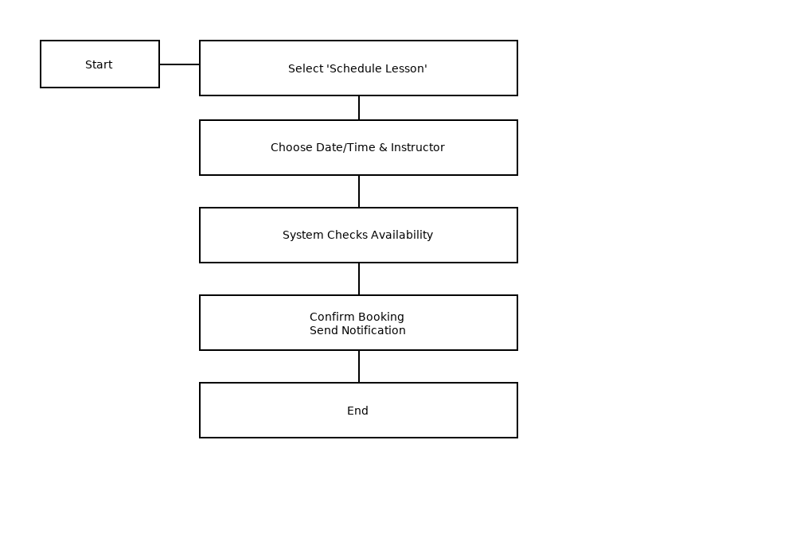

### UML Sequence Diagram

Sequence Diagram provided for the "Schedule Lesson" use case, showing interactions between Customer, DriverPass System, Secretary, and Instructor. Diagram included below.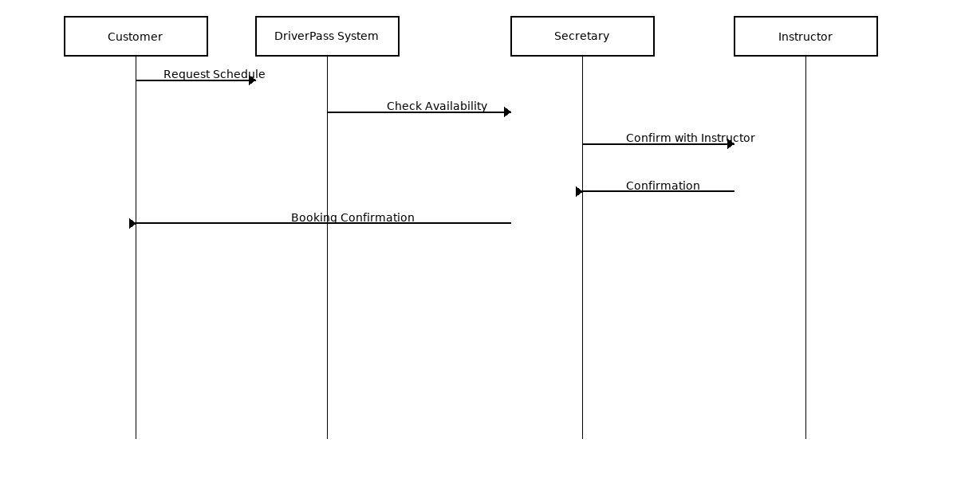

### UML Class Diagram

Class Diagram provided showing primary system classes and their attributes: Customer, Instructor, Secretary, ITOfficer, Owner, Lesson, Appointment, Course, PracticeTest. Diagram included below.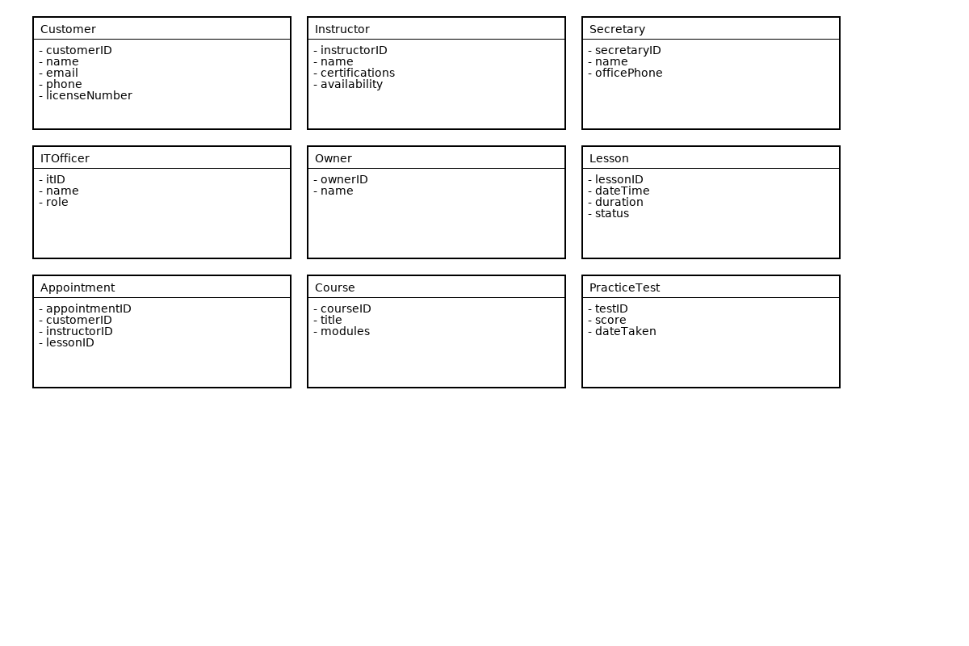

## Technical Requirements

Technical Requirements (hardware, software, tools, infrastructure) are detailed in the section below.

Hardware: Server: 4+ CPU cores, 8GB+ RAM, 100GB disk (cloud VM recommended). Client devices: modern browsers on desktop/mobile.

Software: Web server (Nginx), Application server (Node.js/Java/.NET), Database (PostgreSQL/MySQL), Frontend (React/Vue).

Security & Infrastructure: TLS/HTTPS, OAuth2/JWT, Role-based access control, Email/SMS gateway, backups and monitoring.